Computer Architecture and Organization

**UCS507**

**LAB ASSIGNMENT**

**Computer Science Engineering Department**



# THAPAR INSTITUTE OF ENGINEERING

# AND TECHNOLOGY, PATIALA

**Submitted By : Submitted To :**

Yashwant Ms. Swati Sharma

101803318

COE15

**INDEX**

|  |  |
| --- | --- |
| 1. Write a program in ARM assembly language to add and subtract two 32-bit numbers using: i ) Direct addressing mode=2 ii) Indirect addressing mode=2 iii) Barrel shifter=4 | 3 |
| 2. Write a program to perform left and right shift of a number. =4 | 7 |
| 3. Write a program to find whether number is even or odd. =1 | 8 |
| 4. Write a program to perform Multiplication using addition. =1 | 9 |
| 5. Write a program to store Multiplication table of a number. =1 | 9 |
| 6. Write a program to perform Division using subtraction. =1 | 10 |
| 7. Write a program to find the factorial of a number. | 11 |
| 8. Write a program in ARM assembly language to find 1’s and 2’s compliment. | 12 |
| 9. Write a program in ARM assembly language to find greater of two numbers | 12 |
| 10. Write a program to perform 64-bit addition of two 64-bit number. | 13 |
| 11. Write a program to find the largest and smallest number in an array. | 13 |
| 12. Write a program to find the sorting in an array. | 14 |
| 13. Write a program to copy an array. | 16 |
| 14. Write a program to count the number of characters in a given string. | 17 |
| 15. Write a program to find the number of occurrences of a particular character in a string. | 18 |
| 16. Write a program to add two integer strings | 19 |
| 17. Write a program in ARM assembly language to implement the following equation: i) ax2+by2 ii) 6(x + y) +2z+4 | 19 |
| 18. Write a program in ARM assembly language to verify how many bytes are present in a given set which resemble 0xAC. | 21 |
| 19. Write a program in ARM assembly language to count the number of 1s and 0s in a given byte and verify the result. | 22 |
| 20. Write a program in ARM assembly language for transferring of block of data (e.g. block transfer of 10 numbers from one memory location to another e.g. 0x00000030 to 0x00000300.) | 23 |

**1. Write a program in ARM assembly language to add and subtract two 32-bit numbers using: i ) Direct addressing mode=2 ii) Indirect addressing mode=2 iii) Barrel shifter=4**

i) Direct Addressing

Addition :

AREA PROGRAM, CODE, READONLY

ENTRY

LDR R1,VALUE1

LDR R2,VALUE2

ADD R2,R1,R2

AREA PROGRAM, DATA, READONLY

VALUE1 DCD &00000006

VALUE2 DCD &00000002

END

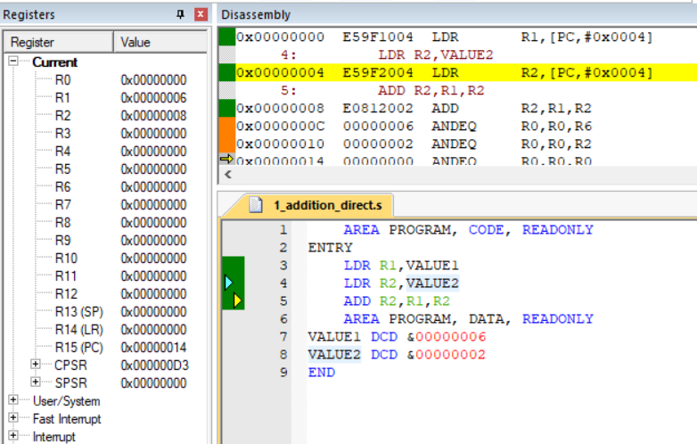

Subtraction :

AREA PROGRAM, CODE, READONLY

ENTRY

LDR R1,VALUE1

LDR R2,VALUE2

SUB R2,R1,R2

AREA PROGRAM, DATA, READONLY

VALUE1 DCD &00000006

VALUE2 DCD &00000002

END

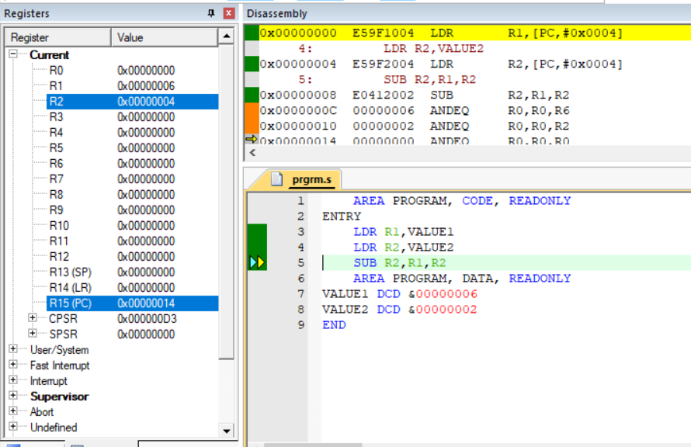

ii) Indirect Addressing

Addition :

AREA PROGRAM, CODE, READONLY

ENTRY

LDR R1,VALUE1

LDR R2,VALUE2

LDR R3,[R1]

LDR R4,[R2]

ADD R5,R3,R4

AREA PROGRAM, DATA, READONLY

VALUE1 DCD &00000200

VALUE2 DCD &00000300

END

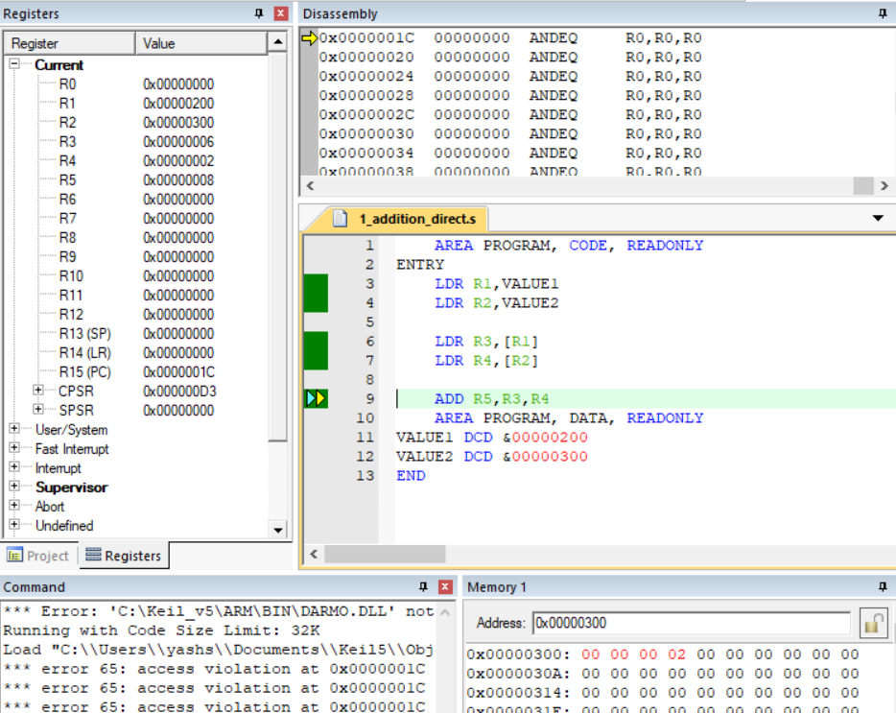

Subtraction :

AREA PROGRAM, CODE, READONLY

ENTRY

LDR R1,VALUE1

LDR R2,VALUE2

LDR R3,[R1]

LDR R4,[R2]

SUB R5,R3,R4

AREA PROGRAM, DATA, READONLY

VALUE1 DCD &00000200

VALUE2 DCD &00000300

END

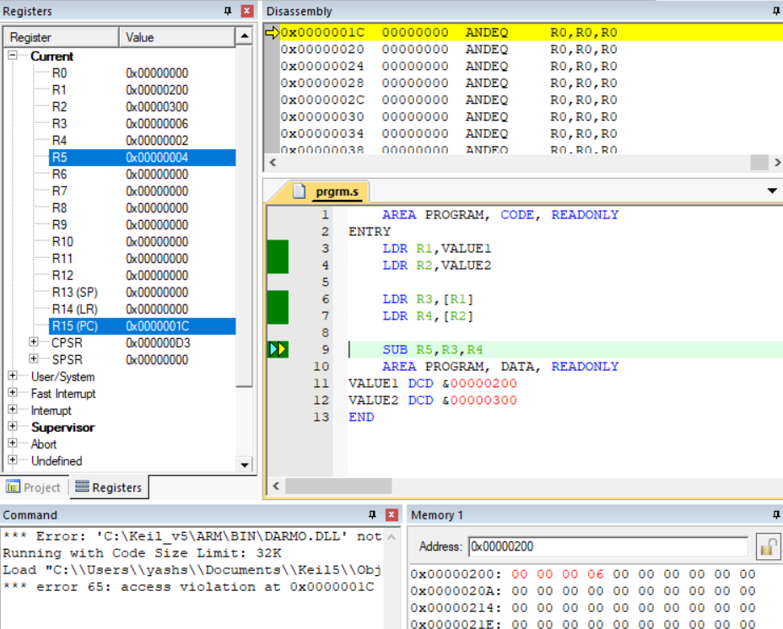

iii) Barrel Shifter

Addition :

AREA PROGRAM, CODE, READONLY

ENTRY

LDR R1,VALUE1

MOV R2,R1,LSL#0x02

ADD R3,R1,R2

AREA PROGRAM, DATA, READONLY

VALUE1 DCD &00000001

END

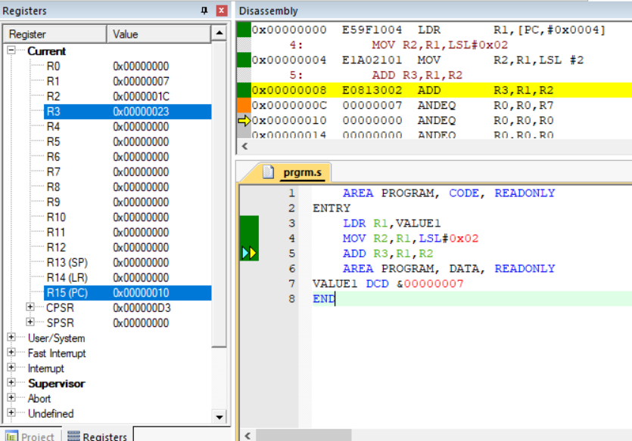

Subtraction :

AREA PROGRAM, CODE, READONLY

ENTRY

LDR R1,VALUE1

MOV R2,R1,LSL#0x02

SUB R3,R2,R1

AREA PROGRAM, DATA, READONLY

VALUE1 DCD &00000007

END

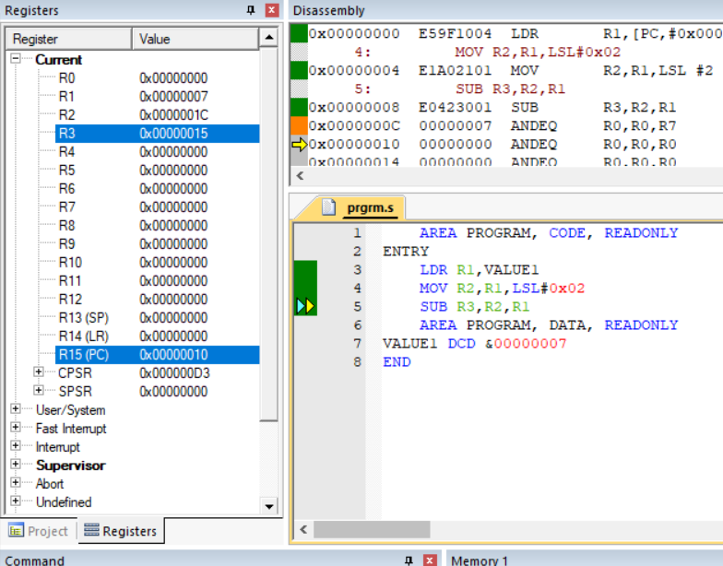

**2. Write a program to perform left and right shift of a number. =4**

AREA PROGRAM, CODE, READONLY

ENTRY

LDR R1,VALUE1

MOV R2,R1,LSL#0x02

MOV R3,R1,LSR#0x02

MOV R4,R1,ASR#0x01

MOV R5,R1,ROR#0x04

AREA PROGRAM, DATA, READONLY

VALUE1 DCD &00000004

END

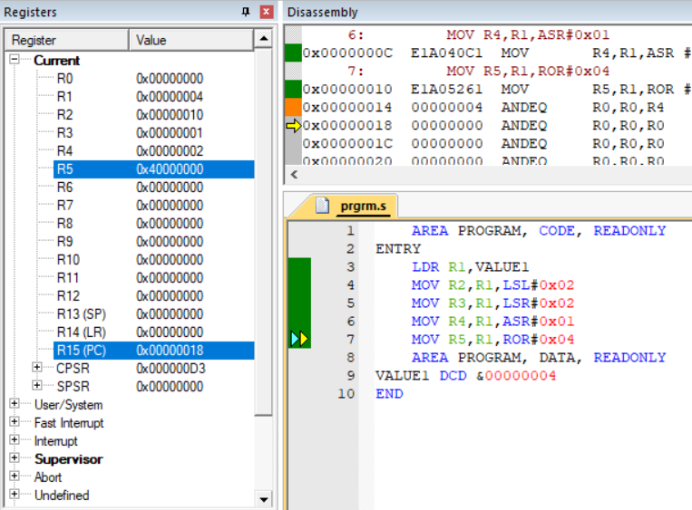

**3. Write a program to find whether number is even or odd. =1**

AREA PROGRAM, CODE, READONLY

ENTRY

LDR R1,VALUE1

LDR R2,VALUE2

MOV R3,#0x01

AND R4,R1,R3

AND R5,R2,R3

AREA PROGRAM, DATA, READONLY

VALUE1 DCD &00000004

VALUE2 DCD &00000007

END

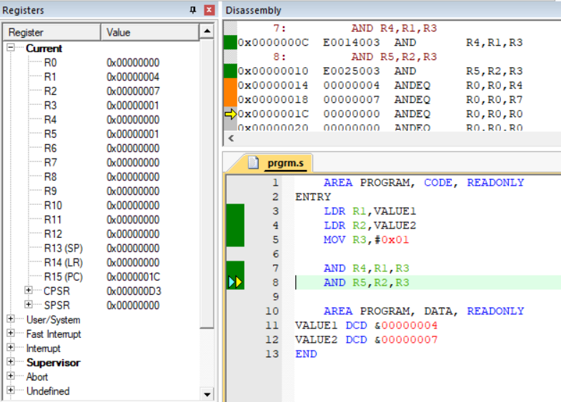

**4. Write a program to perform Multiplication using addition. =1**

AREA PROGRAM, CODE, READONLY

ENTRY

LDR R1,VALUE1

LDR R2,VALUE2

MOV R3,#0x00

MOV R4,R2

LOOP

ADD R3,R3,R1

SUB R4,R4,#0x01

CMP R4,#0x00

BNE LOOP

AREA PROGRAM, DATA, READONLY

VALUE1 DCD &00000004

VALUE2 DCD &00000007

END

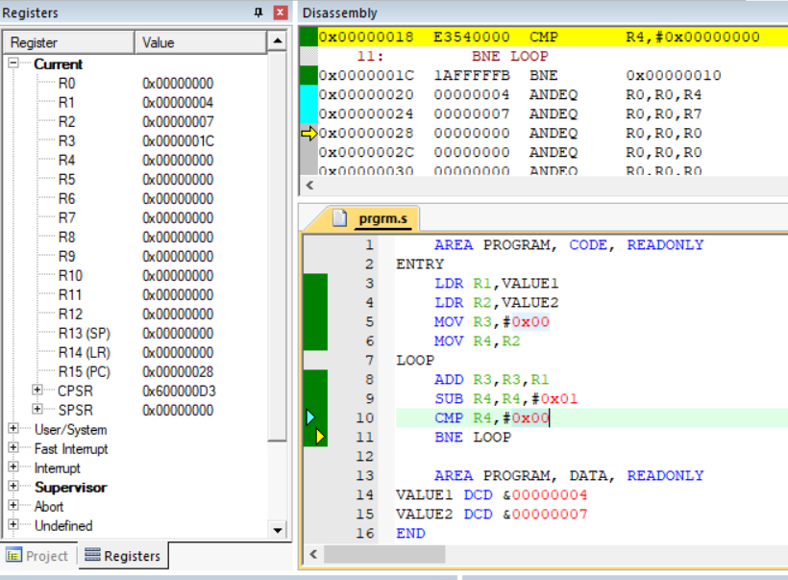

**5. Write a program to store Multiplication table of a number. =1**

AREA PROGRAM, CODE, READONLY

ENTRY

LDR R1,VALUE1

LDR R2,VALUE2

MOV R3,#0x0A

MOV R4,R1

LOOP

STR R1,[R2]

ADD R1,R1,R4

ADD R2,R2,#0x04

SUB R3,R3,#0x01

CMP R3,#0x00

BNE LOOP

AREA PROGRAM, DATA, READONLY

VALUE1 DCD &00000002

VALUE2 DCD &00000400

END

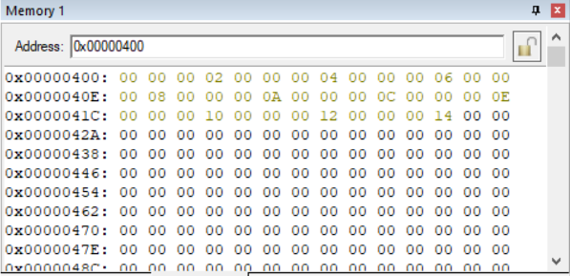

**6. Write a program to perform Division using subtraction. =1**

AREA PROGRAM, CODE, READONLY

ENTRY

LDR R1,VALUE1 ;10

LDR R2,VALUE2 ;2

MOV R3,#0x00

MOV R4,R1

LOOP

SUB R4,R4,R2

ADD R3,R3,#0x01

CMP R4,#0x00

BNE LOOP

AREA PROGRAM, DATA, READONLY

VALUE1 DCD &0000000A

VALUE2 DCD &00000002

END

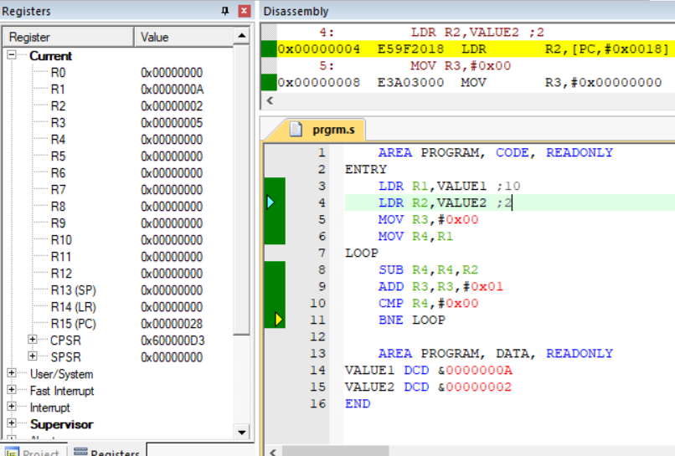

**7. Write a program to find the factorial of a number.**

AREA PROGRAM, CODE, READONLY

ENTRY

LDR R1,VALUE1 ;4

MOV R2,#0x01

MOV R3,R1

LOOP

MUL R0,R1,R2

MOV R1,R0

ADDS R2,R2,#0x01

CMP R3,R2

BNE LOOP

AREA PROGRAM, DATA, READONLY

VALUE1 DCD &00000004

END

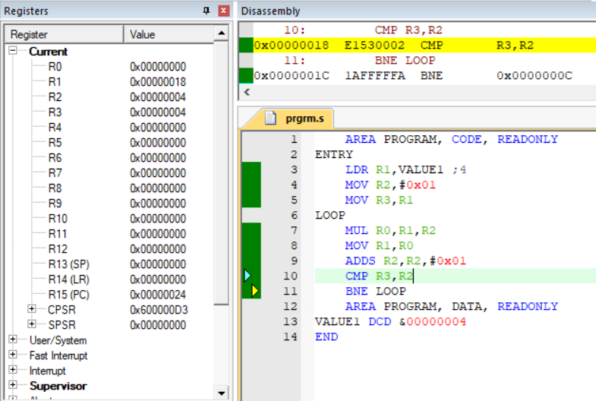

**8. Write a program in ARM assembly language to find 1’s and 2’s compliment.**

AREA PROGRAM, CODE, READONLY

ENTRY

MOV R1,#0x00000008

MVN R2,R1 ;move with negation = 1's complement

NEG R3,R1 ;move with negation+1 = 2's complement

AREA PROGRAM, DATA, READONLY

END

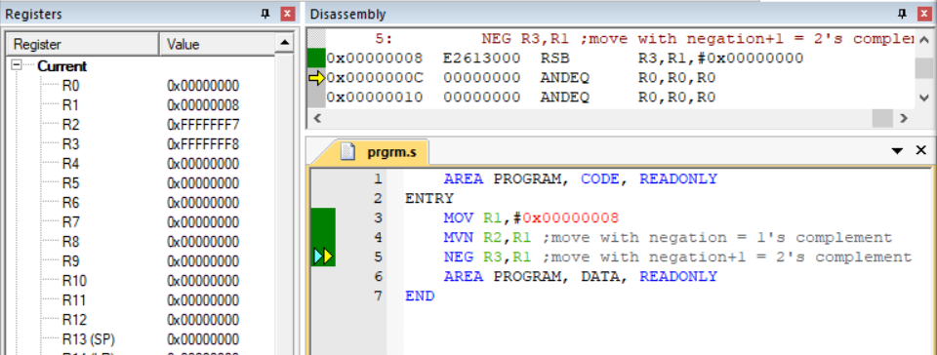

**9. Write a program in ARM assembly language to find greater of two numbers.**

AREA PROGRAM, CODE, READONLY

ENTRY

MOV R1,#0x00000008

MOV R2,#0x00000003

MOV R3,#0x00000000

CMP R1,R2

MOVGT R3,R1 ; MOVE R1 TO R3 IF GREATER

MOVLE R2,R1 ; MOVE R2 TO R3 IF GREATER

AREA PROGRAM, DATA, READONLY

END

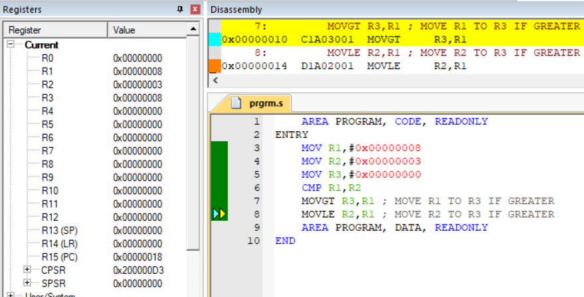

**10. Write a program to perform 64-bit addition of two 64-bit number.**

AREA PROGRAM, CODE, READONLY

ENTRY

LDR R0,=VALUE1 ; pointer to value1

LDR R1,=VALUE2 ; pointer to value2

LDR R2,[R0] ; load 1st part(11111111) to r2

LDR R3,[R0,#4] ; load 2nd part(22222222) to r3

LDR R4,[R1] ; load 1st part(22222222) to r4

LDR R5,[R1,#4] ; load 2nd part(33333333) to r5

ADDS R6,R3,R5 ; adds r3,r5 and sets the carry

ADC R7,R2,R4 ; adds r2,r4 and carry

LDR R8,=RESULT ; pointer to result variable

STR R6,[R8] ; store r6 to first part of r8

STR R7,[R8,#4] ; stores r7 to second part of r8

AREA PROGRAM, DATA, READONLY

VALUE1 DCD &11111111,&22222222

VALUE2 DCD &22222222,&33333333

RESULT DCD 0

END

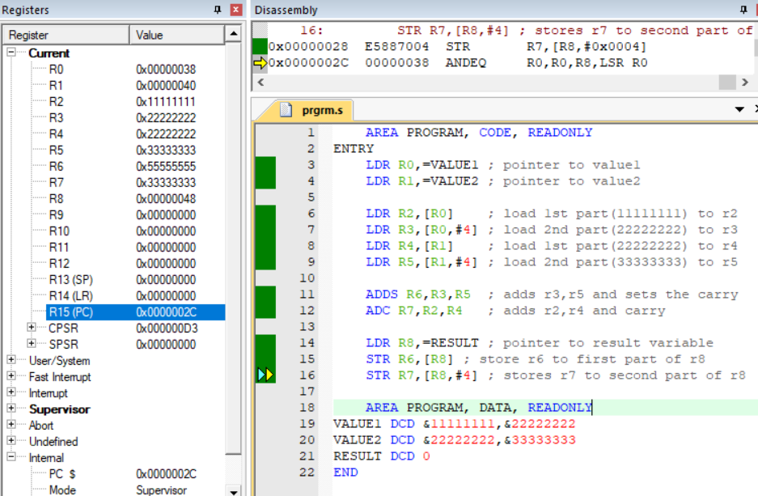

**11. Write a program to find the largest and smallest number in an array.**

AREA PROGRAM, CODE, READONLY

ENTRY

LDR R0,=A ; LDR 32-bit num | pointer to A's first num

LDR R1,N ; holds count

;LDRB 8-bit num

LDRB R4,[R0] ; will hold smallest num

LDRB R5,[R0] ; will hold largest value

LOOP

LDRB R6,[R0],#0x01 ; point to next

CMP R6,R4

MOVLT R4,R6

CMP R6,R5

MOVGT R5,R6

SUB R1,#0x01

CMP R1,#0x00

BNE LOOP

AREA PROGRAM, DATA, READONLY

N DCD &00000008 ; number of elements

A DCB 1,2,6,3,4,7,3,2 ;define constant byte = 8 bits

END

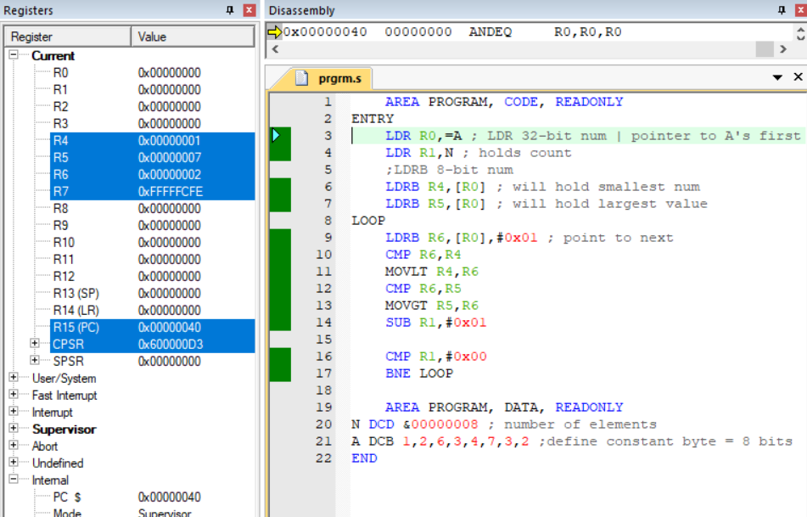

**12. Write a program to find the sorting in an array.**

AREA PROGRAM,CODE,READONLY

ENTRY

LDR R0,=arr

MOV R1,#0X08 ;outer loop counter

ADD R0,R0,#0X07

outerloop

MOV R2,#0X07 ;inner loop counter

SUB R0,R0,#0X07

innerloop

LDRB R3,[R0]

LDRB R4,[R0,#0X01]

CMP R3,R4

BLT loop

MOV R5,R4

MOV R4,R3

MOV R3,R5

loop

STRB R3,[R0]

STRB R4,[R0,#0X01]

ADD R0,R0,#0X01

SUB R2,R2,#0X01

CMP R2,#0X00

BNE innerloop

SUB R1,R1,#0x01

CMP R1,#0X00

BNE outerloop

AREA PROGRAM,DATA,READONLY

arr DCB 1,10,6,3,4,7,8,2 ;define constant byte=8bits

END

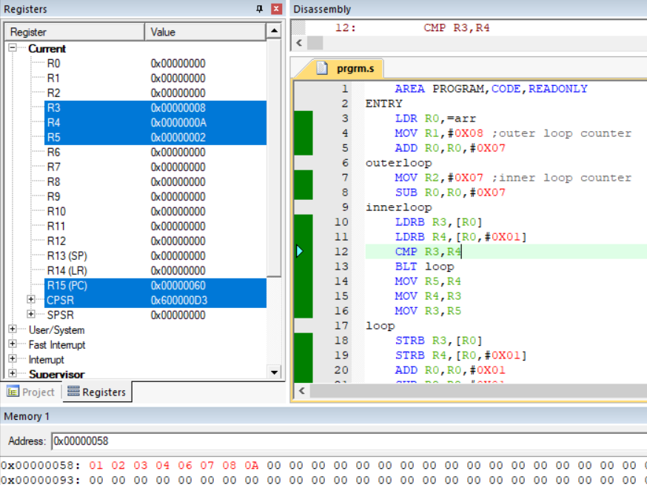

**13. Write a program to copy an array.**

AREA PROGRAM,CODE,READONLY

ENTRY

LDR R0,=ST

MOV R4,#0x04

LDR R5,VALUE1

LOOP

LDRB R2,[R0],#0x01

STRB R2,[R5],#0x01

SUB R4,R4,#0x01

CMP R4,#0x00

BNE LOOP

AREA PROGRAM,DATA,READONLY

ST DCB 1,2,3,4

VALUE1 DCD &00000080

END

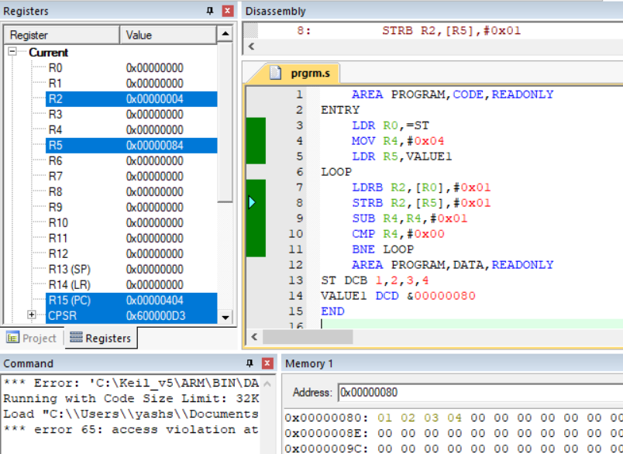

**14. Write a program to count the number of characters in a given string.**

AREA PROGRAM,CODE,READONLY

ENTRY

MAIN

LDR R0,=string

MOV R2,#0x00

LOOP

LDRB R1,[R0],#0x01

CMP R1,#0x00

ADDNE R2,R2,#0x01

BNE LOOP

SWI &11

AREA PROGRAM,DATA,READONLY

string DCB "ABCDEF"

END

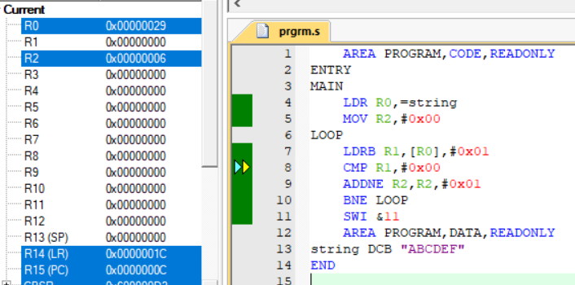

**15. Write a program to find the number of occurrences of a particular character in a string.**

AREA PROGRAM,CODE,READONLY

ENTRY

MAIN

LDR R0,=string

MOV R2,#0x00

LOOP

LDRB R1,[R0],#0x01

CMP R1,#"A"

ADDEQ R2,R2,#0x01

CMP R1,#0x00

BNE LOOP

SWI &11

AREA PROGRAM,DATA,READONLY

string DCB "YASHWANTSAINI"

END

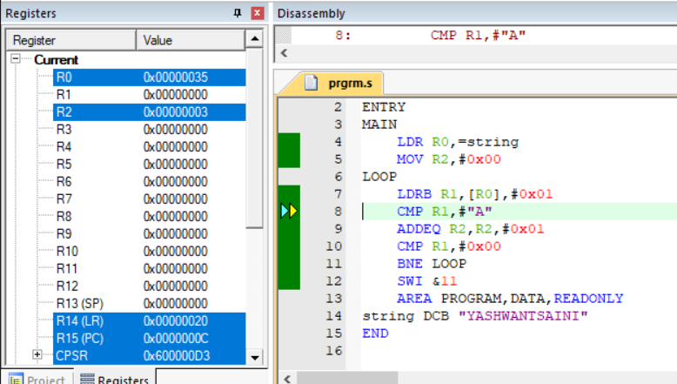

**16. Write a program to add two integer strings.**

AREA PROGRAM,CODE,READONLY

ENTRY

LDR R0, =STR1

MOV R4, #0X04

LDR R1, =STR2

LDR R5,VALUE

LOOP

LDRB R2,[R0], #0x001

LDRB R3,[R1], #0x001

ADD R6,R2,R3

STRB R6,[R5], #0x01

SUB R4,R4,#1

CMP R4,#0

BNE LOOP

AREA PROGRAM,DATA,READONLY

STR1 DCB 1,9,8,7

STR2 DCB 6,2,5,1

VALUE DCD &00000400

END

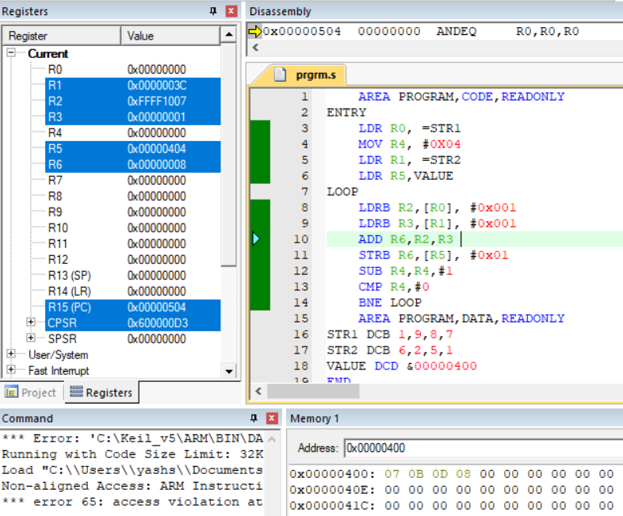

**17. Write a program in ARM assembly language to implement the following equation: i) ax2+by2 ii) 6(x + y) +2z+4.**

i)

AREA PROGRAM,CODE,READONLY

ENTRY

LDR R0,a

LDR R1,b

LDR R2,x

LDR R3,y

MUL R4,R2,R2

MUL R5,R0,R4

MUL R6,R3,R3

MUL R7,R6,R1

ADD R8,R5,R7

AREA PROGRAM,DATA,READONLY

a DCD &00000001

b DCD &00000002

x DCD &00000008

y DCD &00000004

END

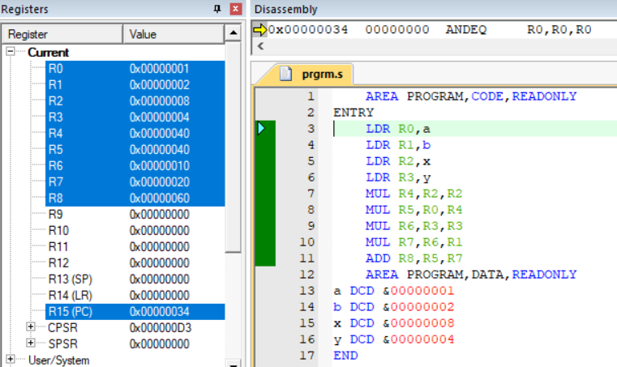

ii)

AREA PROGRAM,CODE,READONLY

ENTRY

LDR R0,x

LDR R1,y

LDR R2,z

MOV R3,#0x06

MOV R4,#0x02

ADD R5,R0,R1

MUL R6,R5,R3

MUL R7,R2,R4

ADD R8,R7,R6

ADD R8,R8,#0x04

AREA PROGRAM,DATA,READONLY

x DCD &00000002

y DCD &00000003

z DCD &00000002

END

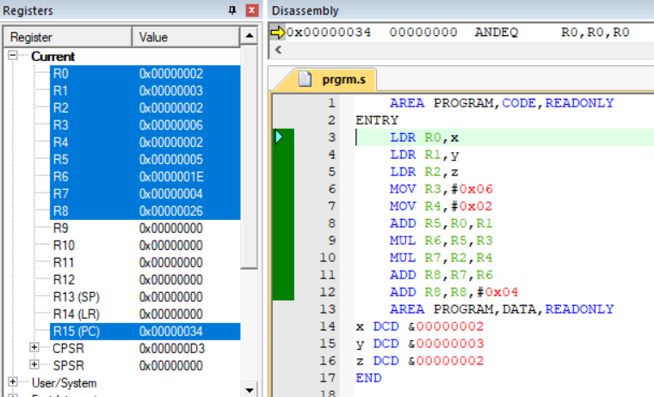

**18. Write a program in ARM assembly language to verify how many bytes are present in a given set which resemble 0xAC.**

AREA PROGRAM,CODE,READONLY

ENTRY

LDR R0,value

MOV R3,#0x0A ;counter

LOOP

LDRB R1,[R0],#0x01

CMP R1,#0xAC

ADDEQ R2,R2,#1 ;R2 stores count of 0xAC

SUBS R3,R3,#1

CMP R3,#0x00

BNE LOOP

AREA PROGRAM,DATA,READONLY

value DCD &00000200

END

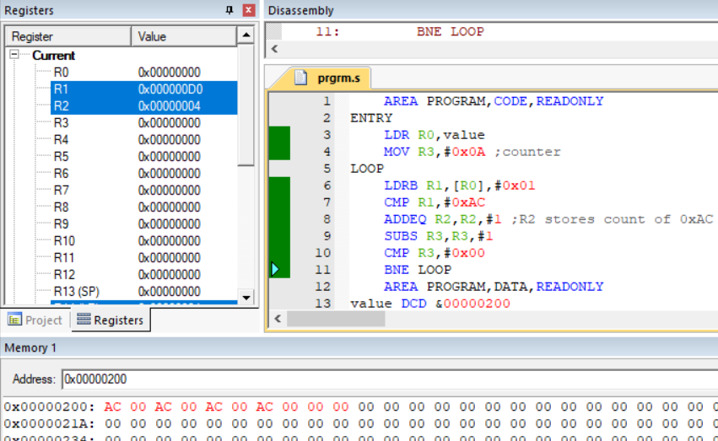

**19. Write a program in ARM assembly language to count the number of 1s and 0s in a given byte and verify the result.**

AREA PROGRAM,CODE,READONLY

ENTRY

MAIN

LDR R0, VALUE1

MOV R1, #0x20 ;counter for 32 bit number

MOV R2, #0x00 ;store number of 1s

MOV R3, #0x00 ;store number of 0s

LOOP

MOVS R0, R0, RRX ; ROTATE RIGHT BY 1

ADDCS R2, R2, #0x01 ;increment number of 1s ,add if carry is set

ADDCC R3, R3, #0x01 ; ;increment number of 0s , add if carry is clear

SUBS R1, R1, #0x01 ; STOPPING CRITERIA

CMP R1,#0x00

BNE LOOP ;

AREA PROGRAM, DATA, READONLY

VALUE1 DCD &11100111

END

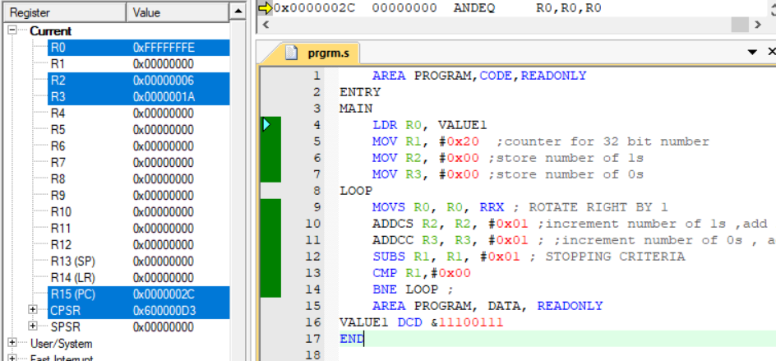

**20. Write a program in ARM assembly language for transferring of block of data (e.g. block transfer of 10 numbers from one memory location to another e.g. 0x00000030 to 0x00000300.)**

AREA PROGRAM,CODE,READONLY

ENTER

LDR R0,VALUE1

LDR R1,VALUE2

MOV R2,#0x0A

LOOP

LDR R3,[R0],#4

STR R3,[R1],#4

SUB R2,R2,#1

CMP R2,#0x00

BNE LOOP

AREA PROGRAM,DATA,READONLY

VALUE1 DCD &000000030

VALUE2 DCD &000000070

END

